**EXPERIMENT 4**

RELATIONAL MODEL FOR SAILOR BOAT DATABASE

**Aim:** Draw a relational model for sailors database

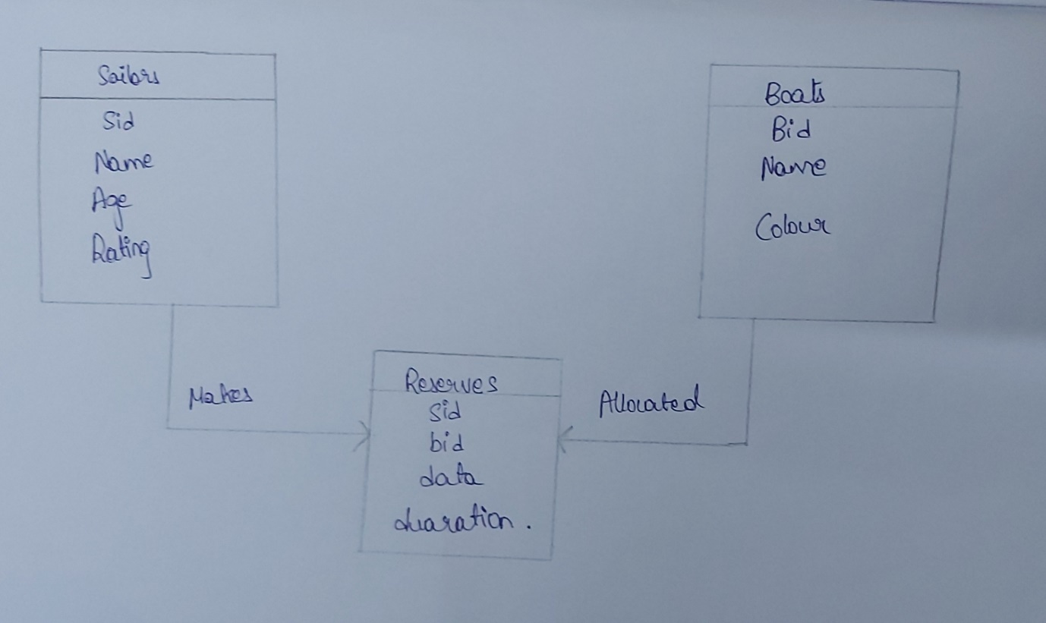

Sid

name

Age

Rating

Sid

Bid

Data

Duration

Bid

name

color

**Sailor**

**Reservation**

**Boats**

Makes

allocated